MLD Assignment 1&2: EDA & Model

Sourabh, Huy, Han

The goal of this EDA is to understand what the effect of minorities and racial/ethnic groups on mortgage lending is, and to conclude the finding.

The dataset contains 1989 observation and 8 NA variables. The summary of data shows as below:

* There are 1989 records with no missing values
* Majority of loans are approved
* Most people are not black
* Mostly people credit conditions are met
* Almost all loan applicants are non-Hispanic
* Male applicants are male
* Majority of people applying for loan are married
* We have false data in dataset:
* Credit meet has a value (666) for 2 records
* Male and married have 15 and 3 observations with value (.)

This data contains some missing value, so removed them select the subset of data.

The approval rate of loan is 87.7%. The Black applicants takes up to 9.9%, and the Hispanic applicants takes up to 5.6% among all the applicants. 80.7% of the applicants are male, while 18.6% are female and 0.8% did not tell the gender. 65.8% applicants are married, while 34.1% are not and 0.2% did not tell.

The following graph presents the condition of income and the ratio of loan/purchase from left to right. We can find that over half of the loan applicants are over 25% other obligations as a total income and at the same time, over half of the applicants are over 0.6 as their rate of loan and purchase, which means half of them need to loan money in order to satisfy their purchase.



The graph below shows a more specific statistic result. The mean of the other obligations is likely to be 35% and the mean of loan/purchase is almost 0.75. However, the result also indicates there are outliers in the sample.



The graph below indicates that the other obligations is not strong correlated with the rate of loan by purchase. The correlation is only 0.2.



Overall Descriptive statistic:

1. Approval Rate: (0 for no, 1 for yes)

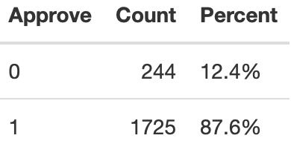

1. Married:

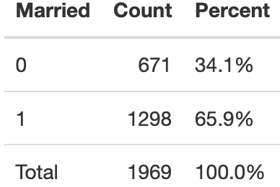

1. GLIND:

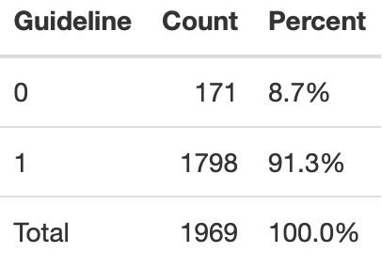

1. Rate of Black:

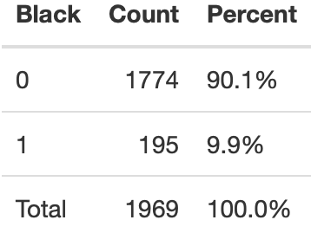

1. Rate of Hispanic:

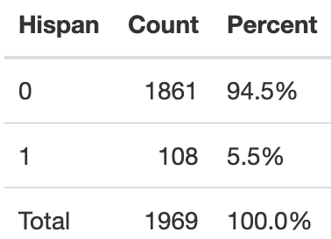

1. Rate of Male:

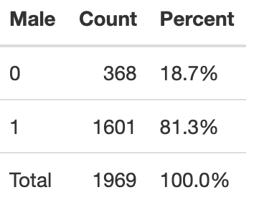

1. Other obligation:

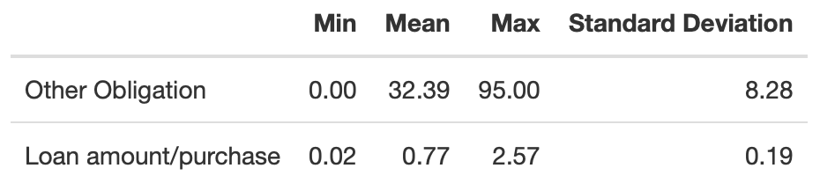

Black subset Descriptive Statistic: (195 observations)

1. Approval rate: 67.2%
2. Married rate: 61.5%
3. GLIND: 72.8%
4. Male: 73.8%
5. Other obligation: min=5.6, mean=34.9, max=63, Std = 8.19
6. Loan amount/purchase: min = 0.29, mean = 0.84, max = 2.56, std = 0.18

Hispanic subset Descriptive Statistic: (108 observations)

1. Approval rate: 75.9%
2. Married rate: 71.3%
3. GLIND: 85.2%
4. Male: 79.6%
5. Other obligation: min=14.6, mean=33.47, max=62, Std = 8.46
6. Loan amount/purchase: min = 0.4, mean = 0.86, max = 1.63, std = 0.14

Logit Model:

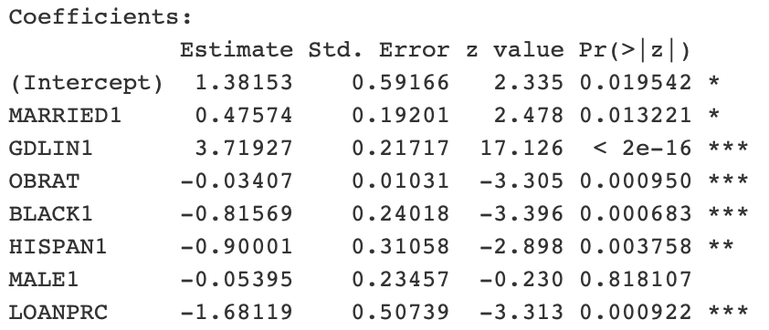

This logit model is to predict the approval probability.

For example, for a married black male, the probability to be approval is calculated as below:

Z = 1.38153 + 0.47574 -0.81569 – 0.05395 = 0.98763

So P(y=1|x) = 1/(1+ $e^{-0.98763}$) \* 100% = 72.86%

For a married black woman, the probability to be approval is:

Z = 1.38153 + 0.47574 – 0.81569 = 1.04158

P = 73.92%

The odd ratio between man and woman is $e^{-0.05395}=94.75\%$, which means when holding other factors constant, the probability of approval of male is 5.25% less than female.

The odd ratio between married and single is $e^{0.47574}=160.92\%$, which means when holding other factors constant, the probability of approval for the married applicators is 60.92% higher than the single applicators.

The odd ratio of black applicator is $e^{-0.81569}=44.23\%$, which means when holding other factors constant, the probability of approval for black applicator is 55.77% less than not black applicators.

The odd ratio of Hispanic applicator is $e^{-0.90001}=40.66\%$, which means that when holding other factors constant, the probability of approval for Hispanic applicators is 59.34% lower than not Hispanic applicators.

Probit Model:

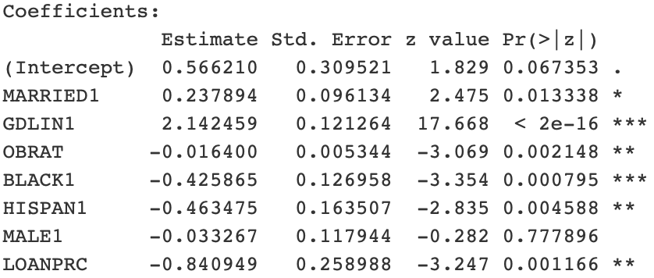

The probit model is similar to logit model to predict the probability of loan approval.

For example, for a married black male, the probability to be approved is calculated as:

Z = 0.56621 + 0.237894 – 0.425865 – 0.033267 = 0.344972

So, P(y=1|x) = G(Z) = 0.6349 = 63.49%

For a married black woman, the probability to be approval is:

Z = 0.56621 + 0.237894 – 0.425865 = 0.378239

P = G(0.378239) = 64.74%